COMPUTER ENGINEERING STUDIES
A project report on:
HOMOMORPHIC ENCRYPTION

Prepared by: ANSHIKA MEHNDIRATTA (U07CO205)
BHAVNA SHIVNANI (U07CO209)
A. V. ARUNA (U07CO212)

Class : B.TECH IV (Computer Engineering) 7th Semester

Year : 2010-2011

Guided by : DR. D. C. JINWALA,
HEAD OF DEPT. AND ASSOCIATE PROFESSOR


DEPARTMENT OF COMPUTER ENGINEERING
SARDAR VALLABHBHAI NATIONAL INSTITUTE OF TECHNOLOGY,
SURAT - 395 007 (GUJARAT, INDIA)

Certificate
This is to certify that the project preliminary report entitled Homomorphic Encryption is prepared and presented by, Anshika Mehndiratta, Bhavna Shivnani and A.V. Aruna, bearing Roll No.s: U07CO205, U07CO209 and U07CO212 respectively, Final Year of Computer Engineering and their work is satisfactory.

SIGNATURE:

GUIDE JURY HEAD OF DEPT.

ABSTRACT

A combination of symmetric and asymmetric encryption techniques are used to securely transmit the sensitive data over the insecure Internet. To perform any processing of such sensitive data without giving access to it requires the use of fully homomorphic encryption scheme, which requires heavy computation. This becomes a significant factor if are using resource constrained small portable devices. This gives rise to the need of Elliptic Curve Cryptography (ECC), which offers equivalent security with smaller key sizes, which can be computed with low resources. Our project is to implement test programs of three ECC (Elliptic Curve Cryptography) algorithms: ECIES (Integrated Encryption Scheme), ECDSA (Digital Signature Algorithm), ECDH (Diffie Hellman) and do their profiling to perform a comparative study of their execution time and resource consumptions.

Keywords – Fully Homomorphic Encryption, ECC (Elliptic Curve Cryptography), ECIES (Integrated Encryption Scheme), ECDSA (Digital Signature Algorithm), ECDH (Diffie Hellman)
TABLE OF CONTENTS

SR. NO. | TOPIC | PAGE NO.
1. | List of Figures ....................................................................................... |  | I
2. | List of Tables ………………………………………………………… |  | II
3. | Nomenclature ........................................................................................ |  | III
4. | Chapter 1: Introduction ......................................................................... |  | 1
5. | Chapter 2: Theoretical Background ......................................................  2.1 Homomorphic Encryption ..............................................  2.2 Wireless Sensor Networks ..............................................  2.3 Elliptic Curve Cryptography .......................................... |  | 2  2  6  13
6. | Chapter 3: Related Work ....................................................................... |  | 18
7. | Chapter 4: Problem Statement .............................................................. |  | 20
8. | Chapter 5: Implementation ...................................................................  5.1 Methodology of Evaluation ............................................  5.2 Tools investigated ...........................................................  5.3 Test Application ..............................................................  5.4 Profiling Tools Investigated.............................................  5.5 Profiling ......................................................................... |  | 21  21  25  28  33  35
9. | Chapter 6: Profiling Results  6.1 Runtime  6.2 Memory Consumption  6.3 Power Consumption |  | 37  37  44  51
10. | Chapter 7: Conclusion & Future Work ................................................. |  | 56
11. | Bibliography ......................................................................................... |  | III
12. | Acknowledgement ................................................................................ |  | IV

LIST OF FIGURES

FIGURE NO. |  | TOPIC | PAGE NO.
5.1 | Block Diagram for methodology of evaluation .................................................. |  |  | 21
5.2 | Block Diagram for investigation of ECC libraries ……..................................... |  |  | 22
5.3 | Block Diagram for implementation of ECC algorithms .................................... |  |  | 23
5.4 | Block diagram for investigation of profiling tool …………………………….. |  |  | 24
5.5 | Block diagram for profiling of ECC algorithm………………………………... |  |  | 25
5.6 | Block diagram for ECIES ……………………………………………………. |  |  | 30
5.7 | Block diagram for ECDSA ……………………………………………………. |  |  | 31
5.8 | Block diagram for ECDH ……………………………………………………. |  |  | 32
6.1 | Graph of Runtime (microseconds) of ECIES and ECDSA |  |  | 37
6.2 | Plot of sample readings of runtime of ECIES ………………………………… |  |  | 39
6.3 | Plot of sample readings of runtime of ECDSA ………………………………. |  |  | 41
6.4 | Plot of sample readings of runtime of ECDH ………………………………… |  |  | 43
6.5 | Graph of Heap memory Consumption (bytes) of ECIES and ECDSA ……….. |  |  | 44
6.6 | Plot of Sample Readings for heap memory consumed (bytes) by ECIES ……. |  |  | 45
6.7 | Screenshot of result obtained by msprint command in massif tool for ECIES .. |  |  | 46
6.8 | Plot of Sample Readings for heap memory consumed (bytes) by ECDSA …... |  |  | 47
6.9 | Screenshot of result obtained by msprint command in massif tool for ECDSA |  |  | 48
6.10 | Plot of Sample Readings for heap memory consumed (bytes) by ECDH ……. |  |  | 49
6.11 | Screenshot of result obtained by msprint command in massif tool for ECDH .. |  |  | 50
6.12 | Graph of Total Instruction Fetch Cost of ECIES and ECDSA ………………... |  |  | 51
6.13 | Screenshot of results obtained in Kcachegrind for ECIES …………………… |  |  | 52
6.14 | Screenshot of results obtained in Kcachegrind for ECIES …………………… |  |  | 53
6.15 | Screenshot of results obtained in Kcachegrind for ECIES …………………… |  |  | 54

LIST OF TABLES

TABLE NO. |  | TOPIC | PAGE NO.
6.1 | Runtime (microseconds) for ECIES, ECDSA and ECDH ………………………... |  |  | 37
6.2 | Sample readings for Runtime of ECIES ………………………………………….. |  |  | 38
6.3 | Sample readings for Runtime of ECDSA ……………………………………........ |  |  | 40
6.4 | Sample readings for Runtime of ECDH …………………………………………... |  |  | 42
6.5 | Heap memory consumption (bytes) for ECIES, ECDSA and ECDH …………….. |  |  | 44
6.6 | Sample Readings for peak values of heap memory consumed (bytes) by ECIES .. |  |  | 45
6.7 | Sample Readings for peak values of heap memory consumed (bytes) by ECDSA . |  |  | 47
6.8 | Sample Readings for peak values of heap memory consumed (bytes) by ECDH ... |  |  | 49
6.9 | Total Instruction Fetch Cost for ECIES, ECDSA and ECDH …………………….. |  |  | 51

NOMENCLATURE

ABBREVIATION | EXPANSION
ECC | Elliptic Curve Cryptography
ECDSA | Elliptic Curve Digital Signature Algorithm
ECIES | Elliptic Curve Integrated Encryption Scheme
ECDH | Elliptic Curve Diffie Hellman
WSN | Wireless Sensor Networks
PKC | Public Key Cryptography
ANSI | American National Standard Institute
KDF | Key Derivation Function
EEA | Elliptic Euclidean Algorithm
DOS | Denial Of Service
DLIES | Discrete Logarithm Integrated Encryption Scheme
MAC | Message Authentication Code
SHA | Secure Hash Algorithm
ECNR | Elliptic Curve Nyberg Rueppel
ECMQV | Elliptic Curve Menezes–Qu–Vanstone
RTS | Request To Send
CTS | Clear To Send
GCC | GNU Compiler Collection
IDE | Integrated Development Environment
GNU GPL | GNU General Public License

CHAPTER 1
INTRODUCTION

A large portion of Internet applications require the exchange of sensitive data between servers and clients over the Internet. A combination of symmetric and asymmetric encryption techniques are used to securely transmit the sensitive data over the insecure Internet. But any processing of such sensitive data requires giving access to the party which needs to process it. This again gives rises to privacy issues. A solution to this problem could be to enable processing of data without decrypting it. This is possible only if we use a fully homomorphic encryption scheme, which is a form of encryption where a specific algebraic operation is performed on the plaintext and another (possibly different) algebraic operation is performed on the ciphertext. This requires heavy computation, which becomes a significant factor in speed performance as key length grows. Meanwhile, more and smaller portable devices and embedded systems with limited computing and power resources are being used to increase the mobility of the users. Thus, we need a public-key cryptosystem, like Elliptic Curve Cryptography (ECC), that offers equivalent security with smaller key sizes, which can be computed with less processing power, memory, and lower power consumption.
Our project is to implement test programs of three ECC (Elliptic Curve Cryptography) algorithms: ECIES (Integrated Encryption Scheme), ECDSA (Digital Signature Algorithm), ECDH (Diffie Hellamn) and do their profiling to perform a comparative study of their execution time and resource consumptions.
Firstly, we have included the theoretical background consisting of Homomorphic encryption followed by Wireless Sensor Networks and ECC. It is followed by the various libraries being investigated in the process and finally arriving at CryptoPP library on which our test programs of ECIES, ECDSA and ECDH were implemented. The different libraries we worked before getting the final one are TinyECC and libecc. Then we have chosen callgrind as the profiling tool for memory and power consumption and gettimeofday() system call of time consumption. Based on profiling results, analysis has been done for usage as per user requirements and system constraints. After all this, we have discussed about the scope of future research areas.

CHAPTER 2
THEORETICAL BACKGROUND

2.1 HOMOMORPHIC ENCRYPTION [4]
2.1.1 Definition
Homomorphic encryption is a form of encryption where a specific algebraic operation is performed on the plaintext and another (possibly different) algebraic operation is performed on the ciphertext such that the decryption of result of algebraically processed ciphertext is same as that of the result of algebraically processed plaintext. Thus, homomorphic encryption helps to process data without compromising on the privacy of the data.
Homomorphic encryption scheme helps to reconcile privacy and convenience to some extent since it allows anyone manipulate encrypted data in a meaningful way without knowing the secret key.

2.1.2 Functionality
Homomorphic encryption scheme ε has three algorithms: KeyGen_{ε}, Encrypt_{ε}, and Decrypt_{ε}, all of which must be efficient—that is, run in time poly(λ), polynomial in a security parameter λ that specifies the bit-length of the keys. A homomorphic encryption scheme can be either symmetric or asymmetric. The complexity of asymmetric homomorphic scheme is greater than that of a symmetric homomorphic encryption. The algorithms of homomorphic encryption scheme perform following functions:
- KeyGen_{ε}(constant) produces a single key p for symmetric encryption and public key pk and secret key sk for asymmetric encryption.
- Encrypt_{ε} (pk, m_{i}) produces ciphertext c_{i} for message m_{i} encrypted under pk
- Decrypt_{ε} (sk, c) decrypts c using secret key sk to produce message m
- Evaluate_{ε}, which is associated to a set of permitted functions. For any function f in and any ciphertexts c₁, ..., c_{t} with c_{i} ← Encrypt_{ε} (pk, m_{i}), the algorithm Evaluate_{ε} (pk, f, c₁, ..., c_{t}) outputs a ciphertext c that encrypts f(m₁, ..., m_{t}) — i.e., such that Decrypt_{ε} (sk, c) = f(m₁, ..., m_{t}). ε can handle functions in . For a function f not in , there is no guarantee that Evaluate_{ε} will output anything meaningful. Typically Evaluate_{ε} is undefined for such a function.
2.1.3 Fully Homomorphic Encryption Scheme
The requirements of fully homomorphic encryption scheme are as follows:
- Decryption of c (the ciphertext output by Evaluate_{ε}) takes the same amount of computation as decrypting c₁ (a ciphertext output by Encrypt_{ε})
- c is the same size as c₁. This is called compact ciphertexts requirement
- The size of c and the time needed to decrypt it do not grow with the complexity of f; rather, they are completely independent of f (unless f has multiple outputs).
- The complexity of Decrypt_{ε}, as well as the complexity of KeyGen_{ε} and Encrypt_{ε}, must remain polynomial in λ.
- ε can handle all functions.
- The complexity of Evaluate_{ε}—like the other algorithms of ε—to depends only polynomially on the security parameter.

2.1.4 Security
The security requirements are stated as follows:
- The weakest requirement for an encryption scheme is one-wayness: given the public key pk and a ciphertext c that encrypts unknown message m under pk, then an adversary algorithm running in poly(λ) has a negligible probability of success over the choices of pk and m.
- Stronger security property required is semantic security against chosen-plaintext attacks: given a ciphertext c that encrypts either m₀ or m₁, then probability of adversary algorithm, running in poly(λ), guessing correctly should be approx ½.
- A semantically secure encryption scheme must be probabilistic—i.e., there must be many ciphertexts that encrypt a given message, and Encrypt_{ε} must choose one randomly according to some distribution. If an encryption scheme is deterministic—i.e., if there is only one ciphertext that encrypts a given message—then it cannot be semantically secure. An attacker can easily tell whether c encrypts m₀, by running c₀ ←Encrypt(pk, m₀) and seeing if c and c₀ are the same.

2.1.5 Somewhat Homomorphic Encryption Scheme
A somewhat homomorphic encryption scheme ε can handle a limited class of permitted functions. Evaluate_{ε} (pk, f, c₁, ..., c_{t}) does not work for functions f that are too complicated.
When we perform operations on the ciphertext the noise associated to resulting ciphertexts increases. To determine the set of permitted functions that our homomorphic encryption scheme ε can handle, we need to analyze how the noise grows as we perform the function operations on the ciphertexts. The functions that ε can handle are those for which noise is within permissible limits.

2.1.6 Bootstrappable Encryption
If ε has this self-referential property of being able to handle its own decryption function we say that it is bootstrappable.
Suppose that ε is bootstrappable and it can handle the operations of addition, subtraction and multiplication homomorphically. The complete set of circuits consists of:
- decryption function, expressed as a circuit D_{ε} of size polynomial in λ
- D_{ε} augmented by an Add, Sub, or Mult gate modulo 2.
Suppose that ciphertext c₁ encrypts the bit m under key pk₁ and encrypted secret key be a vector of ciphertexts that encrypt the bits of sk₁ under pk₂ via Encrypt_{ε}(pk₂, sk_{1j}). Recrypt_{ε}(pk₂, D_{ε}, , c₁) has following 2 steps
- Generate via Encrypt_{ε} (pk₂, c_{1j}) over the bits of c₁
- Output c ← Evaluate_{ε} (pk₂, D_{ε}, , )
The decryption circuit D_{ε} has input wires for the bits of a secret key and the bits of a ciphertext. Evaluate_{ε} takes in the bits of sk₁ and c₁ , each are encrypted under pk₂. Then, ε is used to evaluate the decryption circuit homomorphically. As long as ε can handle D_{ε}, the output c is an encryption under pk₂ of Decrypt_{ε}(sk₁, c₁) = m. Recrypt_{ε} therefore outputs a new encryption of m, but under pk₂.
One fascinating thing about Recrypt_{ε} is that the message m is doubly encrypted at one point, first under pk₁ and next under pk₂. Ordinarily, the only thing one can do with a doubly encrypted message is to peel off the outer encryption first, and then decrypt the inner layer. It is also useful to imagine that ε is our somewhat homomorphic encryption scheme and consider what Recrypt_{ε} does to the noise of the ciphertexts. Evaluating D_{ε} removes the noise associated to the first ciphertext under pk₁ (because, of course, decryption removes noise), but Evaluate_{ε} simultaneously introduces new noise while evaluating the ciphertexts under pk₂. As long as the new noise added is less than the old noise removed, we have made "progress."

2.1.7 Bootstrappable to Fully Homomorphic Encryption Scheme
A bootstrappable encryption scheme ε can be used to construct a fully homomorphic encryption scheme ε† by recursively using ε we get ε†. The public key in ε† consists of a sequence of public keys (pk₁, ..., pk_{l+1}) and a chain of encrypted secret keys , ..., , where sk_{i} is encrypted under pk_{i+1}. To evaluate a function f in ε†, we express f as a circuit, topologically arrange its gates into levels, and step through the levels sequentially. For a gate at level i + 1 (e.g., an Add gate), we take as input the encrypted secret key and a couple of ciphertexts associated to output wires at level i that are under pk_{i}, and we homomorphically evaluate D_{ε} to get a ciphertext under pk_{i+1} associated to a wire at level i + 1. Finally, we output the ciphertext associated to the output wire of f.
Putting the encrypted secret key bits , ..., in ε†'s public key is not a problem for security. These encrypted secret-key bits are indistinguishable from encryptions of 0 as long as ε is semantically secure.
Strictly speaking, ε† does not quite meet our definition of fully homomorphic encryption, since the complexity of KeyGen_{ε†} grows linearly with the maximum circuit depth we want to evaluate. Suppose that ε is not only bootstrappable, but also circular-secure—that is, it is "safe" to reveal the encryption of a secret key sk_{i} under its own associated public key pk_{i}. Then, we can simplify KeyGen_{ε}†. We do not need distinct public keys pk_{i} for each circuit level and an acyclic chain of encrypted secret keys. Instead, the public key in ε† can consist merely of a single public key pk and a single encrypted secret key (sk under pk), where pk is associated to all levels of the circuit. This approach has the additional advantage that we do not need to decide beforehand the maximal circuit depth complexity of the functions that we want to be able to evaluate.
For most encryption schemes, revealing an encryption of sk under pk does not lead to any attack.

2.1.8 Somewhat Homomorphic to Bootstrappable Encryption Scheme
A somewhat homomorphic encryption scheme is bootstrappable if it can handle its own decryption circuit. To convert a somewhat homomorphic encryption scheme ε to bootstrappable one we need to modify ε slightly, constructing a new (but closely related) somewhat homomorphic scheme ε* that can handle essentially the same functions that ε can, but whose decryption circuit is simple enough to make ε* bootstrappable. This bootstrappable encryption scheme ε* can be used to construct a fully homomorphic encryption scheme.
The transformation steps to construct ε* are as follows:
- In KeyGen_{ε*}(λ): The difference between KeyGen_{ε*} and KeyGen_{ε} is that KeyGen_{ε*} includes a hint about p—namely, a set of numbers that contains a (hidden) sparse subset that sums to 1/p (to within a very small error, and up to addition by an even number). This hint is the used in Encrypt_{ε*} and Decrypt_{ε*}. Although it is technically not the decryption key sk*, the integer p still can be used to decrypt a ciphertext output by Encrypt_{ε*}, so revealing this hint obviously impacts security.
- In Encryp_{tε*}(pk*, m): The hint is used to post process a ciphertext c output by Encrypt_{ε}, with the objective of leaving less work remaining for Decrypt_{ε*} to do.
- In Decrypt_{ε*}(sk*, c*): It is simplified by using gate operations. But this creates small precision errors. To ensure that decryption occurs correctly despite the low precision, becomes smaller than , since but this makes only a small difference.
The encryption key of ε* contains a hint about the secret p. But ε* is semantically secure, unless either it is easy to break the semantic security of ε.
This sort of two-phase approach to decryption has been used before in server-aided cryptography in which a user wants to minimize its cryptographic computation—e.g., because it is using a constrained device, such as a smartcard or handheld. So, it outsources expensive computations to a server. To set up this arrangement, the user (in some schemes) must give the server a hint that is statistically dependent on its secret key sk, but which is not sufficient to permit the server to decrypt efficiently on its own. The server uses the hint to process a ciphertext directed to the user, leaving less work for the user to do. In our setting, the encrypter or evaluator plays the role of the server, post-processing the ciphertext so as to leave less work for the decryption algorithm to do.

2.2 WIRELESS SENSOR NETWORKS [5]
A typical sensor network consists of a large number of small, low-power, low-cost nodes that form a self-organized network using wireless peer-to-peer communication [2].
2.2.1 Limitations of WSN
Individual sensor nodes in a WSN have the inherent limitations in resources, which make the design of security procedures more complicated. These stated below:
- Energy: Sensor nodes typically have a small form factor with a limited amount of battery power. Therefore, protocols designed for sensor networks should utilize only a few control messages. Sensor transducer, communication among sensor nodes and microprocessor computation consumes energy in sensor nodes. Any message expansion caused by security mechanisms comes at a significant cost. Further, higher security levels in WSNs usually correspond to more energy consumption for cryptographic functions.
- Memory: Sensor nodes usually have a small amount of memory. Hence, sensor network protocols should not require the storage of a large amount of information at the sensor node. There is usually not enough space to run complicated algorithms after loading OS and application code. This makes it impractical to use the majority of current security algorithms.
- Transmission range: The communication range of sensor nodes is limited both technically and by the need to conserve energy.
- Fault Tolerance: Sensor nodes are prone to failure. This may be due to a variety of reasons. Loss of battery power may lead to failure of the sensor nodes. Thus, protocols designers should build fault tolerance into their algorithms for improving the utility of sensor networks.
- Self-Organization: Sensor nodes are often air-dropped in hostile or harmful environments. It is not possible for humans to reach these sensor nodes. Besides, it is not possible for humans to repair each sensor node, as often the number of sensor nodes is quite large. Hence, self- organization of sensor nodes to form a connected network is an essential requirement.
- Scalability: The number of sensor nodes in a sensor network can be in the order of hundreds or even thousands. Hence, protocols designed for sensor networks should be highly scalable.

2.2.2 Attacks in WSN
- Based On The Capability Of The Attacker
- Outsider Attacks: They are defined as attacks from nodes, which do not belong to a WSN.
- Insider Attacks: They occur when legitimate nodes of a WSN behave in unintended or unauthorized ways.
- Passive Attacks: Passive attacks include eavesdropping on or monitoring packets exchanged within a WSN.
- Active Attacks: They involve some modifications of the data steam or the creation of a false stream.
- Mote-class: In mote-class attacks, an adversary attacks a WSN by using a few nodes with similar capabilities to the network nodes.
- Laptop-class: In laptop-class attacks, an adversary can use more powerful devices (e.g., a laptop) to attack a WSN. These devices have greater transmission range, processing power, and energy reserves than the network nodes.

- Attacks On Information in Transit
- Interruption: Communication link in sensor networks becomes lost or unavailable. This operation threatens service availability. The main purpose is to launch denial-of-service (DoS) attacks. From the layer-specific perspective, this is aimed at all layers.
- Interception: Sensor network has been compromised by an adversary where the attacker gains unauthorized access to sensor node or data in it. Example of this type of attacks is node capture attacks. This threatens message confidentiality. The main purpose is to eavesdrop on the information carried in the messages. From the layer-specific perspective, this operation is usually aimed at the application layer.
- Modification: Unauthorized party not only accesses the data but also tampers with it. This threatens message integrity. The main purpose is to confuse or mislead the parties involved in the communication protocol. This is usually aimed at the network layer and the application layer, because of the richer semantics of these layers.
- Fabrication: An adversary injects false data and compromises the trustworthiness of information. This threatens message authenticity. The main purpose is to confuse or mislead the parties involved in the communication protocol. This operation can also facilitate DOS attacks, by flooding the network.
- Replaying existing messages:
This operation threatens message freshness. The main purpose of this operation is to confuse or mislead the parties involved in the communication protocol that is not time-aware.

- Host-Based Vs Network Based Attacks
- Host-Based Attacks: It is further broken down in to:
- User compromise: This involves compromising the users’ information such as passwords or keys about the sensor nodes.
- Hardware compromise: This involves tampering with the hardware to extract the program code, data and keys stored within a sensor node. The attacker might also attempt to load its program in the compromised node.
- Software compromise: This involves breaking the software running on the sensor nodes. Chances are the operating system and/or the applications running in a sensor node are vulnerable to popular exploits such as buffer overflows.
- Network-based attacks: It has two orthogonal perspectives: layer-specific compromises, and protocol-specific compromises. This includes:
- All the attacks on information in transit.
- Deviating from protocol: When the attacker is, or becomes an insider of the network, and the attacker’s purpose is not to threaten the service availability, message confidentiality, integrity and authenticity of the network, but to gain an unfair advantage for itself in the usage of the network, the attacker manifests selfish behaviours, behaviours that deviate from the intended functioning of the protocol.

- Based On Protocol Stack
- Physical Layer:
- Jamming: similar to Denial of service attacks, i.e. constant transmission of packets. This attack is classified into constant, deceptive, random and reactive. Spread spectrum techniques for radio communication can be used as defence.
- Radio Interference: In this the adversary produces large amount of interference intermittently or persistently. Symmetric key algorithms can be used for defence.
- Tampering or Destruction: Attacker extracts sensitive information like cryptographic keys or other data on the node to which it has physical access. Tamper proofing the node's physical package can be used as defence.
- Data Link Layer:
- Continuous Channel Access (Exhaustion): A malicious node disrupts the MAC protocol by continuously requesting or transmitting over the channel and thus causes starvation for the other nodes in the network over the channel. Time division multiplexing for each node can be used as defence.
- Collision: It occurs when two nodes transmit on the same frequency simultaneously causing checksum mismatch at the receiving end. Due to this, the packet is discarded. Error correcting codes can be used as defence.
- Unfairness: It is a kind of partial DOS attack which degrades the performance. Usage of small frames can be used as defence.
- Interrogation: Attacker exhausts node's resources by repeatedly sending RTS messages to elicit CTS responses from a targeted neighbour node. Anti- replay protection and strong link-layer authentication can be used as defence.
- Sybil Attack: Data aggregation in which a single malicious node that acts as multiple Sybil nodes and may include many negative reinforcements to make the aggregated message a false one.
- Network Layer:
- Sink hole: It tries to lure almost all the traffic towards the compromised node creating a metaphorical sinkhole with the adversary at the centre. Geo-routing protocols are resistant to these attacks.
- Hello flood: This attack exploits the Hello packets that are required in many protocols to announce node to their neighbours. Authentication is the key solution to these attacks.
- Node capture: A single node capture is sufficient for the attacker to take over the entire network. Groundbreaking work in WSN is required to avoid this attack.
- Selective forwarding/black hole attack: Malicious nodes refuse to route certain messages and drop them. If they drop al packets, it is called a blackhole attack and if they drop them selectively then it is called selective forwarding attack. Multipath routing can be used to avoid this attack.
- Sybil attack: A single node presents multiple identities to all other nodes in WSN thus misleading the other nodes and their paths. A unique shared symmetric key for each node with the base station can be used to avoid this attack.
- Wormhole attack: An adversary can tunnel messages received in one part of the network over a low latency link and replay them in another part of the network. To overcome this, the traffic is routed to the base station along a path, which is geographically the shortest.
- Spoofed, altered or replayed routing information: Targets the routing information itself while it is being exchanged between two nodes. Appending a MAC after the message can overcome this.
- Acknowledgement spoofing: Attacker spoofs the acknowledgements of overheard packets destined for neighbouring nodes in order to provide false information to them. Authentication via encryption of all sent packets and packet headers can be use d as a solution.
- Misdirection: Malicious node present in the routing path can send the packets in the wrong direction through which the destination is unreachable. The victim mode can be scheduled to sleep mode for some time to overcome this.
- Internet smurf attack: In this the adversary floods the victim node's network link. The victim mode can be scheduled to sleep mode for some time to overcome this.
- Homing: The attacker uses traffic pattern analysis to get the key network and then jams/destroys it using DOS. Header encryption is a common prevention technique.
- Transport Layer:
- Flooding: Attacker repeatedly makes new connection requests until the maximum limit is reached or the resources are exhausted. As a defence against this, a limit can be put on the number of connections from a particular node.
- De-synchronisation Attacks: In this, the attacker repeatedly forges messages to one or both end points which request transmission of missed frames. A possible solution is to require authentication of all packets including control fields communicated between hosts.
- Application Layer:
- Overwhelm Attack: An attacker might overwhelm network nodes with sensor stimuli, causing the network to forward large volumes of traffic to a base station. This consumes network bandwidth and drains out node energy. Rate-limiting and data aggregation algorithms can be used to mitigate this attack.
- Path-based DOS Attack: It involves injecting spurious or replayed packets into the network at leaf nodes. Anti replay protection and packet authentication can be used to overcome this.
- Deluge (Reprogram Attack): In this, an intruder hijacks the reprogramming process and takes control of large portions of the network. It can use authentication streams to secure the reprogramming process.

2.2.3 Security Requirements of WSNs
Security services include the following:
- Authentication ensures that the other end of a connection or the originator of a packet is the node that is claimed.
- Access-control prevents unauthorized access to a resource.
- Confidentiality protects overall content or a field in a message. Confidentiality can also be required to prevent an adversary from undertaking traffic analysis.
- Privacy prevents adversaries from obtaining information that may have private content. The private information may be obtained through the analysis of traffic patterns, i.e. frequency, source node, routes, etc.
- Integrity ensures that a packet is not modified during transmission.
- Authorization of another node to update information (import authorization) or to receive (export authorization).
- Anonymity hides the source of a packet or frame. It is a service that can help with data confidentiality and privacy.
- Non-repudiation proves the source of a packet. In authentication the source proves its identity. Non-repudiation prevents the source from denying that it sent a packet.
- Freshness ensures that a malicious node does not resend previously captured packets.
- Availability mainly targets DoS attacks and is the ability to sustain the networking functionalities without any interruption due to security threats.
- Resilience to attacks required to sustain the network functionalities when a portion of nodes is compromised or destroyed.
- Forward secrecy: A sensor should not be able to read any future messages after it leaves the network.
- Backward secrecy: A joining sensor should not be able to read any previously transmitted message.
- Survivability is the ability to provide a minimum level of service in the presence of power loss, failures or attacks. Ability to change security level as resource availability changes is the degradation of security services.

  - ELLIPTIC CURVE CRYPTOGRAPHY
2.3.1 Public Key Cryptography and ECC [1]
Elliptic Curve Cryptography (ECC) is a public key cryptography. In public key cryptography each user or the device taking part in the communication generally have a pair of keys, a public key and a private key, and a set of operations associated with the keys to do the cryptographic operations. Only the particular user knows the private key whereas the public key is distributed to all users taking part in the communication. Some public key algorithm may require a set of predefined constants to be known by all the devices taking part in the communication. ‘Domain parameters’ in ECC is an example of such constants. Public key cryptography, unlike private key cryptography, does not require any shared secret between the communicating parties but it is much slower than the private key cryptography.
The mathematical operations of ECC is defined over the elliptic curve y² = x³ + ax + b, where 4a³ + 27b² ≠ 0. Each value of the ‘a’ and ‘b’ gives a different elliptic curve. All points (x, y) which satisfies the above equation plus a point at infinity lies on the elliptic curve. The public key is a point in the curve and the private key is a random number. The public key is obtained by multiplying the private key with the generator point G in the curve. The generator point G, the curve parameters ‘a’ and ‘b’, together with few more constants constitutes the domain parameter of ECC.
One main advantage of ECC is its small key size. A 160-bit key in ECC is considered to be as secured as 1024-bit key in RSA.

2.3.2 Design Implementation [1]
The primary objective of ECC is to provide a ready-to-use, publicly available software package for ECC-based PKC operations that can be flexibly configured and integrated into sensor network applications. To make sure we achieve this objective, we follow several principles in the design and development of ECC.
- Security: ECC should provide PKC schemes that have proved to be secure. To follow this principle, ECC only includes support for the well-studied ECC schemes such as ECDSA, ECDH, and ECIES, which are defined in the Standards for Efficient Cryptography [10]
- Portability: ECC should run on as many platforms as possible.
- Resource Awareness and Configurability: ECC is implemented carefully to avoid unnecessary resource usage. Moreover, ECC uses a set of optimization switches, which can be turned on or off to achieve different combinations of performance and resource consumptions.
- Efficiency: ECC should be computationally efficient to reduce the battery consumption as well as the delay introduced by PKC operations. We make some design decisions to improve the efficiency of ECC like the type of finite fields over which the ECC operations are performed, adopting almost all existing optimizations for ECC operations.
- Functionality: ECC should support the typical demands for PKC. To follow this principle, the current version of ECC includes a digital signature scheme (ECDSA), a key exchange protocol (ECDH), and a public key encryption scheme (ECIES). These cover all typical uses of PKC.

    - Cryptographic Schemes
- ECDSA - Elliptic Curve Digital Signature Algorithm [6]
Signature algorithm is used for authenticating a device or a message sent by the device. For example consider two devices A and B. To authenticate a message sent by A, the device A signs the message using its private key. The device A sends the message and the signature to the device B. This signature can be verified only by using the public key of device A. Since the device B knows A’s public key, it can verify whether the message is indeed send by A or not.
ECDSA is a variant of the Digital Signature Algorithm (DSA) that operates on elliptic curve groups. For sending a signed message from A to B, both have to agree up on Elliptic Curve domain parameters.
Sender ‘A’ have a key pair consisting of a private key d_{A} (a randomly selected integer less than n, where n is the order of the curve, an elliptic curve domain parameter) and a public key Q_{A} = d_{A} * G (G is the generator point, an elliptic curve domain parameter). An overview of ECDSA process is defined below.
- Signature Generation
For signing a message m by sender A, using A’s private key d_{A}
- Calculate e = HASH (m), where HASH is a cryptographic hash function, such as SHA-1
- Select a random integer k from [1,n − 1]
- Calculate r = x1 (mod n), where (x1, y1) = k * G. If r = 0, go to step 2
- Calculate s = k⁻ ¹(e + d_{A}r)(mod n). If s = 0, go to step 2
- The signature is the pair (r, s)
- Signature Verification
For B to authenticate A's signature, B must have A’s public key Q_{A}
  - Verify that r and s are integers in [1,n − 1]. If not, the signature is invalid
  - Calculate e = HASH (m), where HASH is the same function used in the signature generation
  - Calculate w = s ⁻¹ (mod n)
  - Calculate u₁ = e_{w} (mod n) and u₂ = r_{w} (mod n)
- Calculate (x₁, y₁) = u₁G + u₂Q_{A}
- The signature is valid if x₁ = r(mod n), invalid otherwise

- ECIES – Elliptic Curve Integrated Encryption Scheme [16]
Integrated Encryption Scheme (IES) is a public-key encryption scheme which provides semantic security against an adversary who is allowed to use chosen-plaintext and chosen-ciphertext attacks. The scheme is based on Diffie–Hellman problem. Two incarnations of the IES are standardized: Discrete Logarithm Integrated Encryption Scheme (DLIES) and Elliptic Curve Integrated Encryption Scheme (ECIES), which is also known as the Elliptic Curve Augmented Encryption Scheme or simply the Elliptic Curve Encryption Scheme. These two incarnations are identical up to the change of an underlying group and so to be concrete we concentrate on the latter.
To send an encrypted message to B using ECIES A needs the following information:
- cryptographic suite to be used:
  - KDF, e.g., ANSI-X9.63-KDF with SHA-1 option;
  - MAC, e.g., HMAC-SHA-1-160 with 160-bit keys or HMAC-SHA-1-80 with 80-bit keys;
  - symmetric encryption scheme E, e.g., TDEA in CBC mode or XOR encryption scheme;
- EC domain parameters: (p,a,b,G,n,h) for a curve over prime field or(m,f(x),a,b,G,n,h) for a curve over binary field;
- B's public key: K_{B} (Bob generates it as follows: K_{B} = k_{B}G, where k_{B} is the private key he chooses at random: );
- optional shared information: S₁ and S₂.
To encrypt a message m, A does the following:
- generates a random number and calculates R = rG;
- derives a shared secret: S = P_{x}, where P = (P_{x},P_{y}) = rK_{B} (and );
- uses KDF to derive a symmetric encryption and a MAC keys: ;
- encrypts the message: c = E(k_{E};m);
- computes the tag of encrypted message and S₂: ;
- outputs .
To decrypt the ciphertext B does the following:
- derives the shared secret: S = P_{x}, where P = (P_{x},P_{y}) = k_{B}R (it is the same as the one Alice derived because P = k_{B}R = k_{B}rG = rk_{B}G = rK_{B}), or outputsfailed if P = O;
- derives keys the same way as Alice did: ;
- uses MAC to check the tag and outputs failed if ;
- uses symmetric encryption scheme to decrypt the message m = E ⁻ ¹(k_{E};c).

- ECDH – Elliptic Curve Diffie Hellman [6]
ECDH is a key agreement protocol that allows two parties to establish a shared secret key that can be used for private key algorithms. Both parties exchange some public information to each other. Using this public data and their own private data these parties calculates the shared secret. Any third party, who doesn’t have access to the private details of each device, will not be able to calculate the shared secret from the available public information. An overview of ECDH process is defined below:
For generating a shared secret between A and B using ECDH, both have to agree up on Elliptic Curve domain parameters. Both end have a key pair consisting of a private key d (a randomly selected integer less than n, where n is the order of the curve, an elliptic curve domain parameter) and a public key Q = d * G (G is the generator point, an elliptic curve domain parameter). Let (d_{A}, Q_{A}) be the private key - public key pair of A and (d_{B}, Q_{B}) be the private key - public key pair of B.
1. The end A computes K = (x_{K}, y_{K}) = d_{A} * Q_{B}
2. The end B computes L = (x_{L}, y_{L}) = d_{B} * Q_{A}
3. Since d_{A}Q_{B} = d_{A}d_{B}G = d_{B}dA_{G} = d_{B}Q_{A}. Therefore K = L and hence
x_{K} = x_{L}
Hence the shared secret is x_{K}
Since it is practically impossible to find the private key d_{A} or d_{B} from the public key K or L, it is not possible to obtain the shared secret for a third party.

CHAPTER 3
RELATED WORK

[1] presents the design, implementation, and evaluation of TinyECC, a configurable library for ECC operations in wireless sensor networks. The primary objective of TinyECC is to provide a ready-to-use, publicly available software package for ECC-based PKC operations that can be flexibly configured and integrated into sensor network applications. Different combinations of the optimizations have different execution time and resource consumptions, giving developers great flexibility in integrating TinyECC into sensor network applications. It also reports the experimental evaluation of TinyECC on several common sensor platforms. The evaluation results show the impacts of individual optimizations on the execution time and resource consumptions, and give the most computationally efficient and the most storage efficient configuration of TinyECC.
[2] discusses the state of the art in terms of sensor network security and we examine the practicality of using efficient elliptic curve algorithms and identity based encryption to deploy a secure sensor network infrastructure. It evaluates the potential for realizing this on low-power, long-life devices by measuring power consumption of the operations needed for key management. Its specific contribution to this rapidly developing area is to analyze the feasibility of using a Tate pairing-based approach (which uses ECC) to solve the key distribution problem.
ECC over binary field is of special interest because the operations in binary field are thought more space and time efficient. However, the software implementations of ECC over binary field are still slow, especially on low-end processors that are used in small computing devices such as sensor nodes. [3] discusses the software implementations of ECC on processors with different word sizes.
Our work differs from the above discussed papers in the following ways:
- In [1] TinyECC library requires the support of TinyOS and can only be used for simulation on motes. On the other hand, we are using Cryptopp library which supports real world applications. Also [1] draws conclusions based on mote simulation, whereas we would be deriving the conclusions from profiling results.
- In [2] the library used is MIRACL and the profiler tool is Enprofiler (ARM7DTMI processor based profiler), whereas we are using CryptoPP library and a linux based profiler. The algorithms profiled in [2] are different from the algorithms we are studying. Also, [2] profiles various operations of ECC.
- In [3], EEA algorithm has been profiled on processors of different word sizes whereas we would be profiling three ECC algorithms namely ECIES, ECDSA and ECDH.
CHAPTER 4
PROBLEM STATEMENT

We have to implement test programs of three ECC (Elliptic Curve Cryptography) algorithms: ECIES (Integrated Encryption Scheme), ECDSA (Digital Signature Algorithm), ECDH (Diffie Hellamn) and do their profiling in order to find their execution time and resource consumptions. For this we need to investigate ECC libraries and find a suitable one for implementing the three algorithms. After the implementation of the three algorithms we have to choose an appropriate performance profiling tool to profile them. The results of profiling will help us to perform a comparative study of execution time and resource consumption of ECIES, ECDSA and ECDH.
For the seventh semester, our work was to investigate the available ECC libraries and successfully test and run ECIES and ECDSA. We investigated three ECC libraries namely, TinyECC, libecc and cryptopp and chose cryptopp library as the final one for our project.
In the eighth semester, we implemented ECDH and chose an appropriate profiling tool for profiling subsequent comparison of the three ECC based algorithms.
CHAPTER 5
IMPLEMENTATION

  - METHODOLOGY OF EVALUATION
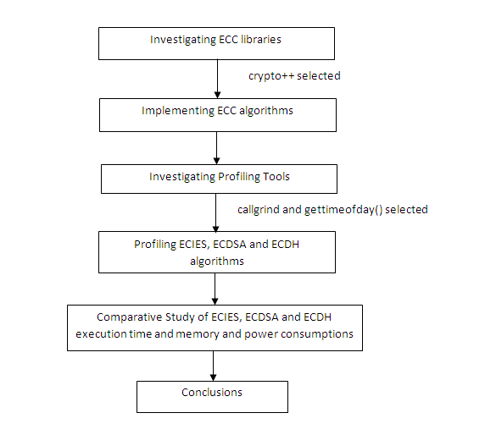
Figure 5.1: Block Diagram for Methodology of Evaluation

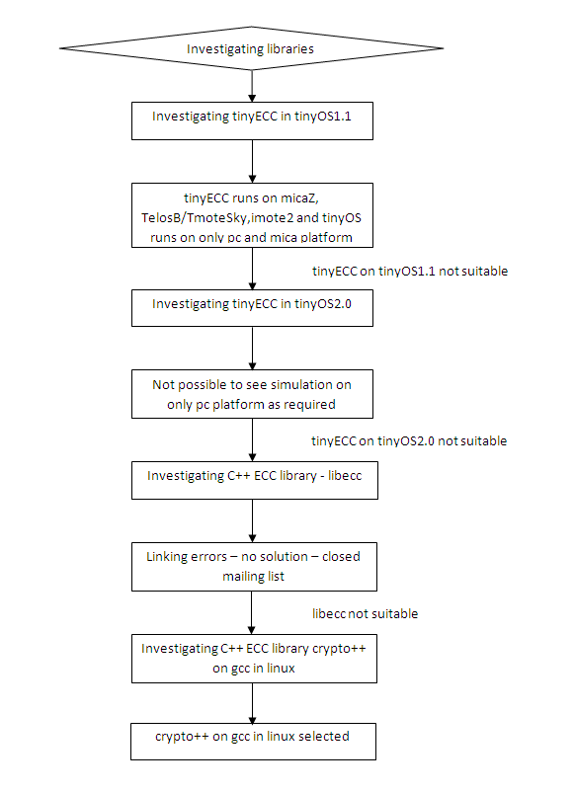
Figure 5.2: Block Diagram for Investigation of ECC libraries

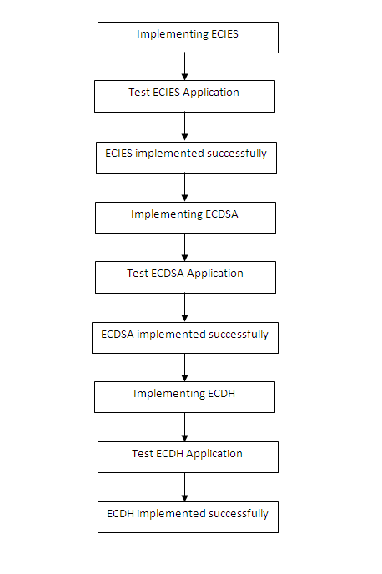
Figure 5.3: Block Diagram for Implementation of ECC algorithms

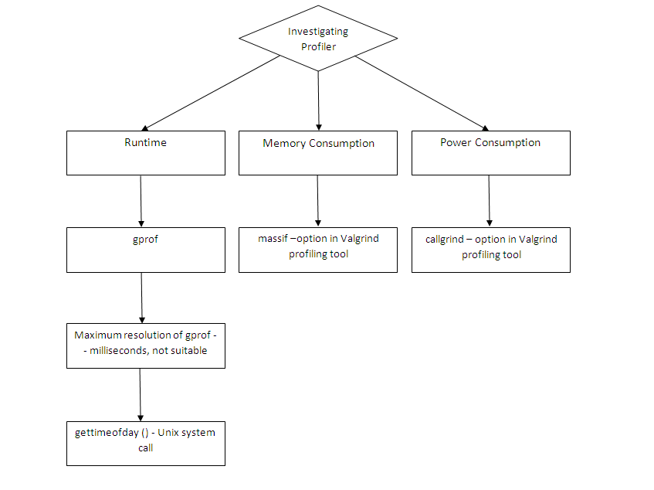
Figure 5.4: Block Diagram for Investigation of Profiling Tool
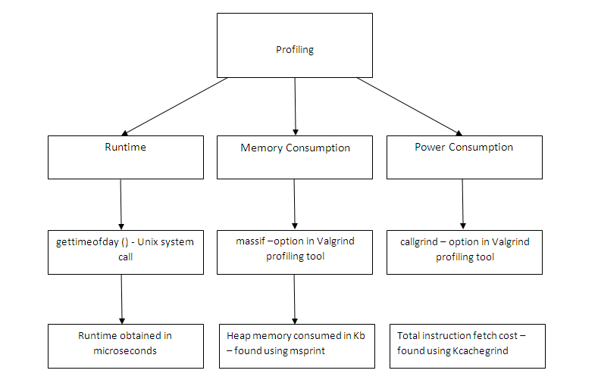
Figure 5.5: Block Diagram for Profiling of ECC algorithms

5.2 TOOLS INVESTIGATED
5.2.1 Libraries Available [7]
- Open source
  - OpenSSL - C library with ECC functionality
  - Crypto++ - C++ library with ECC functionality
  - NSS: Open source crypto libraries with ECC
  - seccure: minimal footprint GPLed ECC tool with public key encryption and digital signatures
  - SKS: very small open source tool for ECC (like a simplified PGP)
  - eccGnuPG: An experimental patch to GnuPG
  - Curve25519: A state-of-the-art Diffie–Hellman function by Dan Bernstein
  - NaCl: Networking and Cryptography library
  - TinyECC: a software package providing ECC operations on TinyOS
  - libecc: Open source ECC library
  - Bouncy Castle: Open source crypto package for Java and C# that includes ECC
  - Eiffel Encryption Library: Open source cryptography library for the Eiffel language

- Proprietary/commercial
- MIRACL: Multi-precision Integer and Rational Arithmetic C/C++ Library
- CNG API in Windows Vista and Windows Server 2008 with managed wrappers for CNG in .NET Framework 3.5
- Sun Java System Web Server 7.0 and later
- Java SE 6
- Java Card
- Security Builder Crypto
- Elliptic Curve Point Multiply and Verify Core

    - Libraries Tested
  - TinyECC [8]
TinyECC is a software package providing ECC-based PKC operations that can be flexibly configured and integrated into sensor network applications. It provides a digital signature scheme (ECDSA), a key exchange protocol (ECDH), and a public key encryption scheme (ECIES). It provides a number of optimization switches, which can turn specific optimizations on or off based on developer's needs.
Problems faced:
  - TinyOS 1.1 supports the following platforms:
    - mica
    - pc
  - Our objective was to simulate on pc platform.
  - But tinyECC runs on following platforms:
    - micaZ,
    - TelosB/ TmoteSky
    - imote2
  - It doesn’t have support for pc platform
  - TinyOS 2.0 supports the platforms required for TinyECC but it not possible to see the simulation on pc.

  - Libecc [9]
'libecc' is a C++ ECC library that supports fixed-size keys for maximum speed. Its goal is to become the first free library to let users generate safe elliptic curves, and to provide an important source of information for anyone with general interest in ECC.
- Platform supported are:
- Turbo C++
- Microsoft Visual C++
- GCC
- Libecc version 0.12.1 was used on platform Microsoft Visual C++ and gcc
- Problems faced: Linking error, which we could not be resolved due to closed mailing list

  - CryptoPP [11]
Crypto++ (also known as CryptoPP, libcrypto++, and libcryptopp) is a free and open source C++ class library of cryptographic algorithms and schemes written by Wei Dai. Crypto++ has been widely used in academia, student projects, open source and non-commercial projects, as well as businesses. It was released in 1995.
- The library fully supports 32-bit and 64-bit architectures on the following operating systems:
    - Apple
    - BSD
    - Linux
    - Windows.
- The project also supports compilation under a variety of compilers and IDEs, including:
    - Borland Turbo C++
    - Borland C++ Builder
    - CodeWarrior Pro
    - GCC (including Apple's GCC)
    - Intel C++ Compiler (ICC)
    - Microsoft Visual C/C++
    - Sun Studio.
- ECC algorithms supported are:
- ECDSA
- ECNR
- ECIES
- ECDH
- ECMQV
- Version investigated was crypto++5.5.2 on GCC in Linux.
- Steps for installation: Commands to be executed on the console are:
- mkdir crypto
- mv cryptopp552.zip ./crypto
- cd crypto
- unzip cryptopp552.zip
- make
- cp libcryptopp.a /usr/lib/
- mkdir /usr/include/cryptopp
- cp *.h /usr/include/cryptopp/
- ldconfig

  - TEST APPLICATION
Our test application consists of 3 algorithms:-
- ECIES
- ESDSA
- ECDH
The test data we used is on “Blood Transfusion Service Centre Data Set” taken from UCLA repository. The fields/attributes of this data set are:
- Recency (months),
- Frequency (times),
- Monetary (c.c. Blood),
- Time (months),"whether he/she donated blood in March 2007"

    - ECIES (Elliptic Curve Integrated Encryption Scheme)
- Pseudocode
generate privatekey
{
Initialise(random_number, secp160r1())
Validate(random_number)
}

generate publickey
{
privateKey.MakePublicKey(publickey)
Validate(random_number)
}

Encryptor(publickey)

Decryptor(privatekey)

while(!eof())
{
open inFile, opFile

plainTextLength=read(inFile)
cipherTextLength=Encryptor.CiphertextLength(plainTextLength)

Encryptor.Encrypt(random_number, plainText.data(), plainTextLength, cipherText)

write(cipherText,opFile)

recoveredTextLength=Decryptor.plaintextlength(cipherTextLength)

Decryptor.Decrypt(random_number, cipherText, cipherTextLength, recoveredText)

Print recoverdText, recoveredTextLength
}

Close inFile,opFile
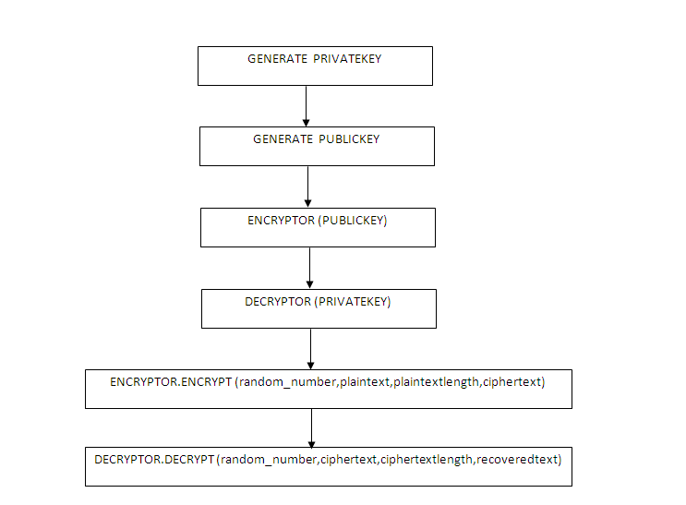
Figure 5.6: Block diagram for ECIES

    - ECDSA (Elliptic Curve Digital Signature Algorithm)
- Pseudocode
generate privatekey
{
Initialise(random_number, secp160r1())
Validate(random_number)
}

generate publickey
{
privateKey.MakePublicKey(publickey)
Validate(random_number)
}

PrintDomainParameters(publicKey)

Print privateKey

Print publicKey

while(!eof())
{
open inFile, opFile
plainTextLength=read(inFile)

//signing the message
StringSource(message,true,SignerFilter(random_number,(privateKey),StringSink(signature )) )

if(signResult == true)
write(signed data,opfile)

//verifying the signed message
StringSource(signature+message,true,SignatureVerificationFilter(publicKey),ArraySink( (verifyResult, sizeof(verifyResult) )))

if(verifyResult == true)
print verification successful
}

close inFile,opFile
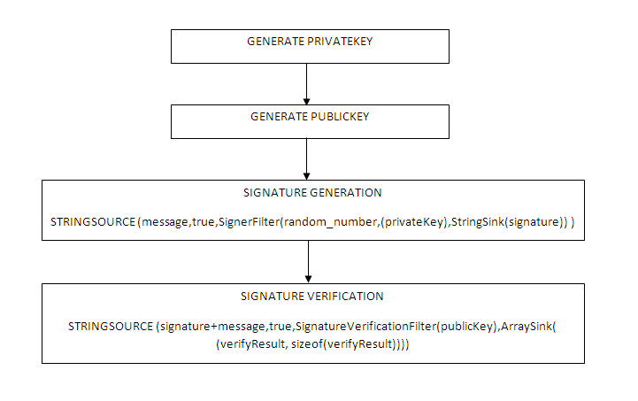
Figure 5.7: Block diagram for ECDSA
    - ECDH (Elliptic Curve Diffie Helman)
- Pseudocode
const CURVE = secp160r1()
ECDHDomain alice = ECDHDomain( CURVE )

alice.GenerateKeyPair (random_number, alice_privateKey, alice_publicKey)

ECDHDomain alice = ECDHDomain( CURVE )

bob.GenerateKeyPair (random_number, bob_privateKey, bob_publicKey)

bob.Agree (bob_agreedValue, bob_privateKey, alice_publicKey)
alice.Agree (alice_agreedValue, alice_privateKey, bob_publicKey)
if ( (alice.AgreedValueLength() == bob.AgreedValueLength())
print ECDH key agreement algorithm is successful

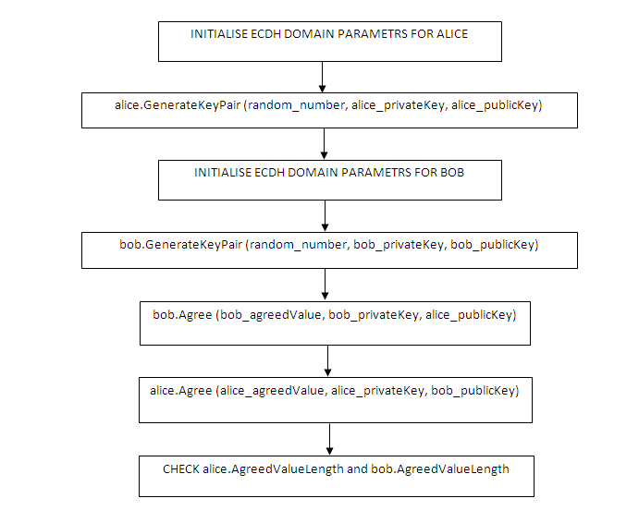
Figure 5.8: Block diagram for ECDH
5.4 PROFILING TOOLS INVESTIGATED
In software engineering, program profiling, software profiling or simply profiling, a form of dynamic program analysis (as opposed to static code analysis), is the investigation of a program's behavior using information gathered as the program executes. The usual purpose of this analysis is to determine which sections of a program to optimize - to increase its overall speed, decrease its memory requirement or sometimes both [17].
Profilers use a wide variety of techniques to collect data, including hardware interrupts, code instrumentation, instruction set simulation, operating system hooks, and performance counters. The usage of profilers is 'called out' in the performance engineering process [17].
Profiling allows you to learn where your program spent its time and which functions called which other functions while it was executing. This information can show you which pieces of your program are slower than you expected, and might be candidates for rewriting to make your program execute faster. It can also tell you which functions are being called more or less often than you expected. This may help you spot bugs that had otherwise been unnoticed [13].
Since the profiler uses information collected during the actual execution of your program, it can be used on programs that are too large or too complex to analyze by reading the source. However, how your program is run will affect the information that shows up in the profile data. If you don't use some feature of your program while it is being profiled, no profile information will be generated for that feature [13].

5.4.1 gprof
The GNU profiler gprof is a useful tool for measuring the performance of a program--it records the number of calls to each function and the amount of time spent there, on a per-function basis. Functions which consume a large fraction of the run-time can be identified easily from the output of gprof. Efforts to speed up a program should concentrate first on those functions which dominate the total run-time [12]. gprof is a profiling program which collects and arranges statistics on your programs. It looks into each of your functions and inserts code at the head and tail of each one to collect timing [13].
We investigated gprof for obtaining the runtime of the three algorithms, viz ECIES, ECDSA and ECDH. The reasons for the unsuitability of gprof profiling tool for our application were:
- the maximum resolution of gprof is milliseconds
- our application requires a microsecond resolution timer.

    - gettimeofday( ) – UNIX system call [17]
The gettimeofday() function shall obtain the current time, expressed as seconds and microseconds since the Epoch, and store it in the timeval structure pointed to by tp. The resolution of the system clock is unspecified.
If tzp is not a null pointer, the behaviour is unspecified. The gettimeofday() function shall return 0 and no value shall be reserved to indicate an error. Its resolution is in microseconds and hence its suitability for to our application.
    - Valgrind [18]
Valgrind is an instrumentation framework for building dynamic analysis tools. There are Valgrind tools that can automatically detect many memory management and threading bugs, and profile your programs in detail. We can also use Valgrind to build new tools.
The Valgrind distribution currently includes six production-quality tools:
- Memcheck - a memory error detector
- Cachegrind - a cache and branch-prediction profiler
- Callgrind - a call-graph generating cache and branch-prediction profiler
- Massif - a heap profiler
- Helgrind - a thread error detector
- Lackey and Nulgrind - testing and demonstrative purposes
It also includes three experimental tools: a heap/stack/global array overrun detector, a second heap profiler that examines how heap blocks are used, and a SimPoint basic block vector generator. It runs on the following platforms: X86/Linux, AMD64/Linux, ARM/Linux, PPC32/Linux, PPC64/Linux, X86/Darwin and AMD64/Darwin
The tools massif and callgrind were considered for profiling the heap memory consumption and power consumption, respectively, of the three algorithms.
- Callgrind, by Josef Weidendorfer, is an extension to Cachegrind. It provides all the information that Cachegrind does, plus extra information about callgraphs. It was folded into the main Valgrind distribution in version 3.2.0. Available separately is an amazing visualisation tool, KCachegrind, which gives a much better overview of the data that Callgrind collects; as is required by our application [19].
- Massif is a heap profiler. It performs detailed heap profiling by taking regular snapshots of a program's heap. It produces a graph showing heap usage over time, including information about which parts of the program are responsible for the most memory allocations. Massif runs programs about 20x slower than normal [19].

  - PROFILING
5.5.1 Runtime
The runtime of the algorithms was calculated using gettimeofday( ) UNIX system call. The specification of gettimeofday() system call is as follows :
#include <sys/time.h>
int gettimeofday(struct timeval *tp, struct timezone *tzp);

Here the argument tzp is used to provide the time zone for obtaining the time value in the argument tp.
An abstraction illustrating the use of gettimeofday() to obtain the runtime of a program is as follows:
#include<sys/time.h>
…
int main()
{
struct timeval *tp1,*tp2;
gettimeofday(tp1,0);
…
gettimeofday(tp2,0);
cout<<”\nSeconds : “,(tp2->tv_sec – tp1->tv_sec));
cout<<”\nMicroseconds : “,(tp2->tv_usec – tp1->tv_usec));
}
By inserting the above code lines in the programs, runtime (in microseconds) for all the algorithms can be obtained.
    - Memory consumption
The massif tool of the Valgrind framework is used to obtain the heap memory
(in bytes) consumed by each algorithm. The massif tool is used as follows:

- valgrind --tool=massif <your-program>
//<your-program> is the C++ program file running the above
//command creates a massif.out.<pid> file, where pid is the process id

- ms_print massif.out.12345 > <program_mem>
//ms_print command generates a graphical output for the massif.out.<pid> file

    - Power Consumption
The callgrind tool of the Valgrind framework is used to obtain the total Instruction Fetch cost of the algorithm. From the total Instruction Fetch cost, power consumed by each algorithm is given as:
Total Power Consumed = Total Instruction Fetch cost * Power consumed by a single instruction
The callgrind tool is used as follows:
  - valgrind --tool= callgrind [callgrind options] <your-program> [program options]
//<your-program> is the C++ program file running the above //command creates a callgrind.out.<pid> file, where pid is the process id
  - kcachegrind ./callgrind.out.<pid>
//kcachegrind is a visualization tool for obtaining the graphical results of callgrind. It takes callgrind.out.<pid> file as argument

CHAPTER 6
PROFILING RESULTS

  - RUNTIME
The following readings were obtained for the runtime (in microseconds) of the three algorithms:
Table 6.1: Runtime (microseconds) for ECIES, ECDSA and ECDH

Algorithm | Runtime (microseconds)
ECIES | 352810
ECDSA | 287332
ECDH | 28027

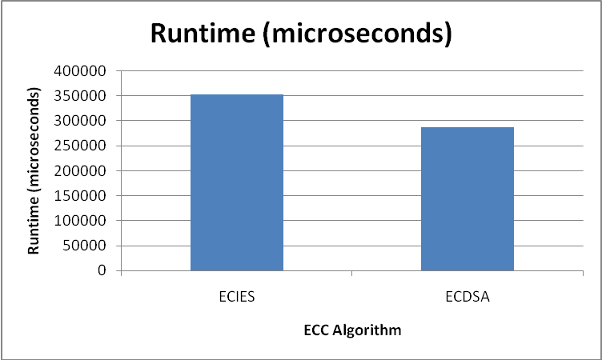
Figure 6.1 : Graph of Runtime (microseconds) of ECIES and ECDSA
Reason for the above results obtained is as follows:
PROGRAM | FUNCTION | RUNTIME (microseconds)
ECIES | Encryptor.Encrypt() | 6614
ECIES | Decryptor.Decrypt() | 4267
EDSSA | Signer.SignandRestart() | 3398
EDSSA | Verifer.VerifyandRestart() | 5859
Twenty readings were taken for the runtime (in microseconds) of each algorithm, and a gross average was calculated to obtain a more accurate result.

Table 6.2: Sample readings for Runtime of ECIES

Snapshot no. | Runtime(microseconds)
1 | 395201
2 | 343926
3 | 371835
4 | 345039
5 | 341178
6 | 353850
7 | 393866
8 | 343300
9 | 317471
10 | 312607
11 | 352208
12 | 369434
13 | 321023
14 | 347158
15 | 393488
16 | 332016
17 | 373339
18 | 354356
19 | 352024
20 | 342877

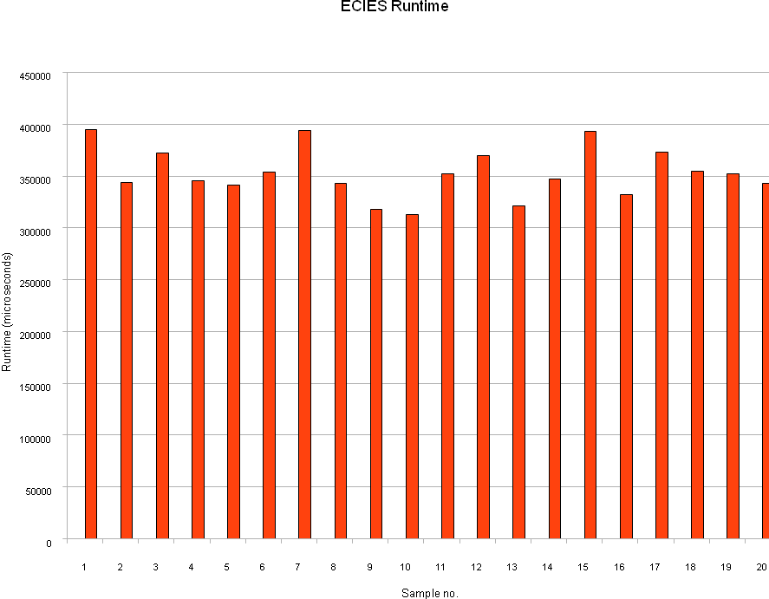
Figure 6.2: Plot of sample readings of runtime of ECIES

Average Runtime for ECIES = 352810 microseconds
Table 6.3: Sample readings for Runtime of ECDSA

Snapshot no. | Runtime(microseconds)
1 | 330246
2 | 287082
3 | 259145
4 | 275542
5 | 285310
6 | 281057
7 | 283870
8 | 307212
9 | 300048
10 | 269442
11 | 305275
12 | 302441
13 | 289183
14 | 293388
15 | 296841
16 | 271045
17 | 272389
18 | 280980
19 | 296164
20 | 259973

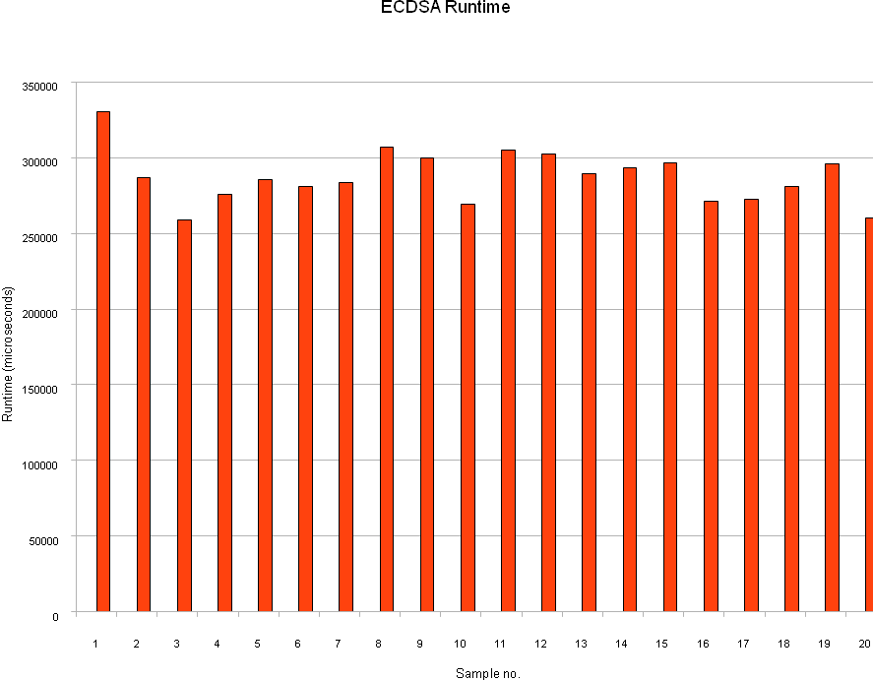
Figure 6.3: Plot of sample readings of runtime of ECDSA

Average Runtime for ECDSA = 287332 microseconds
Table 6.4: Sample readings for Runtime of ECDH

Snapshot no. | Runtime(microseconds)
1 | 28705
2 | 28975
3 | 28553
4 | 28120
5 | 28503
6 | 25214
7 | 29510
8 | 28154
9 | 28748
10 | 28096
11 | 27865
12 | 28120
13 | 28392
14 | 27662
15 | 28247
16 | 28414
17 | 23649
18 | 28738
19 | 28312
20 | 28572

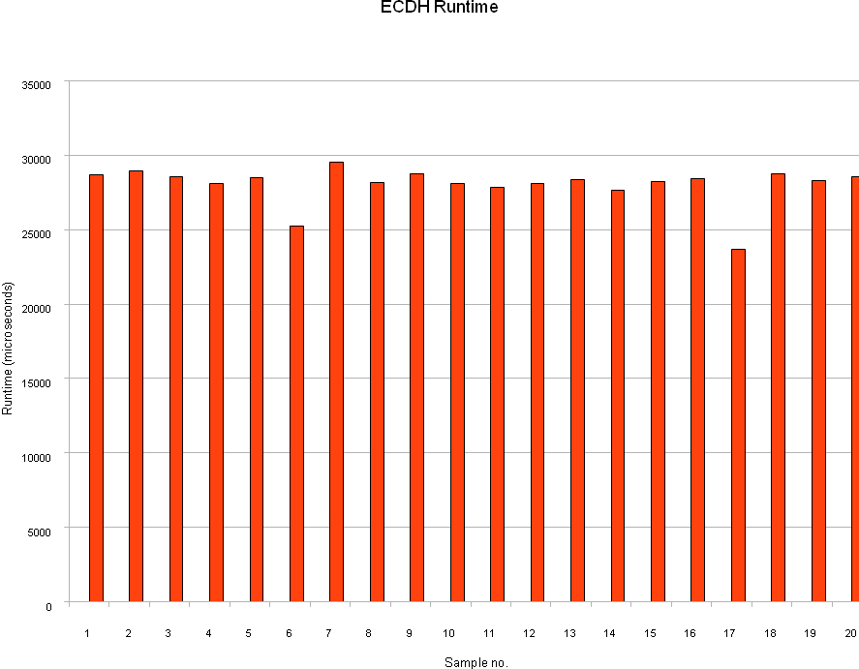
Figure 6.4: Plot of sample readings of runtime of ECDH

Average Runtime for ECIES = 28027 microseconds
6.2 MEMORY CONSUMPTION
Heap memory (bytes) consumed by each algorithm was found out by the massif tool of Valgrind. Obtained below are the snapshots for each of the three algorithms.

Table 6.5: Heap memory consumption (bytes) for ECIES, ECDSA and ECDH

Algorithm | Heap Memory Consumption (bytes)
ECIES | 51424
ECDSA | 43880
ECDH | 15680

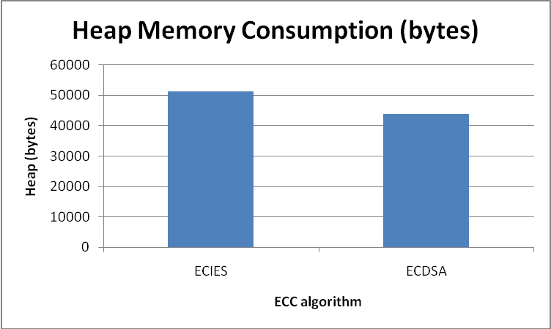
Figure 6.5 : Graph of Heap memory Consumption (bytes) of ECIES and ECDSA

Reason for the above results obtained is as follows:
PROGRAM | FUNCTION | MEMORY (bytes)
ECIES | Encryptor.Encrypt() | 2880
ECIES | Decryptor.Decrypt() | 1536
EDSSA | Signer.SignandRestart() | 512
EDSSA | Verifer.VerifyandRestart() | 704

Table 6.6: Sample Readings for peak values of heap memory consumed (bytes) by ECIES

Sample no. | time(i) | Total Heap | Useful Heap | Extra Heap | Stack
4 | 63423519 | 12008 | 10574 | 1434 | 0
11 (peak) | 152997914 | 51424 | 44546 | 6878 | 0
16 | 227677294 | 36672 | 33234 | 3438 | 0
17 | 248207463 | 40056 | 36073 | 3983 | 0
40 | 550681494 | 39648 | 35657 | 3991 | 0

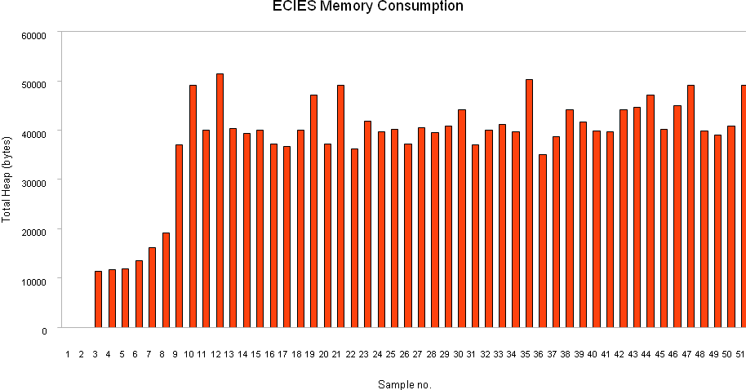
Figure 6.6: Plot of Sample Readings for heap memory consumed (bytes) by ECIES
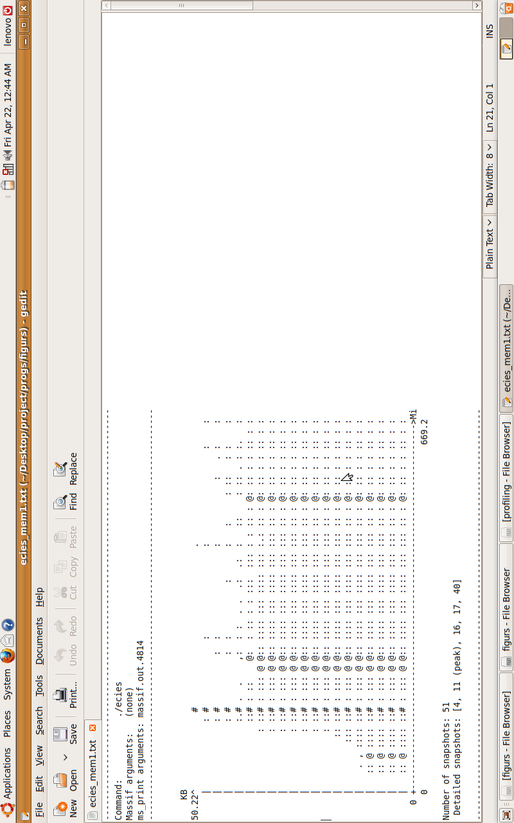
Figure 6.7: Screenshot of result obtained by msprint command in massif tool for ECIES
Table 6.7: Sample Readings for peak values of heap memory consumed (bytes) by ECDSA

Sample no. (n) | time(i) | total heap | useful heap | extra heap | stack
8 | 113303149 | 43424 | 38358 | 5066 | 0
10 (peak) | 139675996 | 43880 | 38710 | 5170 | 0
22 | 305891762 | 42824 | 37942 | 4882 | 0
24 | 334768722 | 35240 | 32149 | 3091 | 0
29 | 392465758 | 35240 | 32149 | 3091 | 0
31 | 421114573 | 33016 | 30454 | 2562 | 0
42 | 556526642 | 35240 | 32149 | 3091 | 0

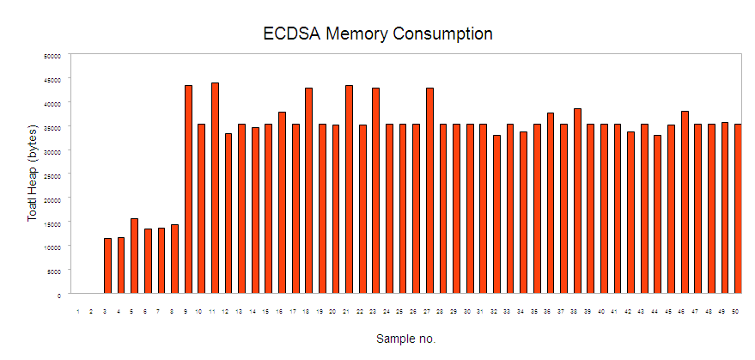
Figure 6.8: Plot of Sample Readings for heap memory consumed (bytes) by ECDSA
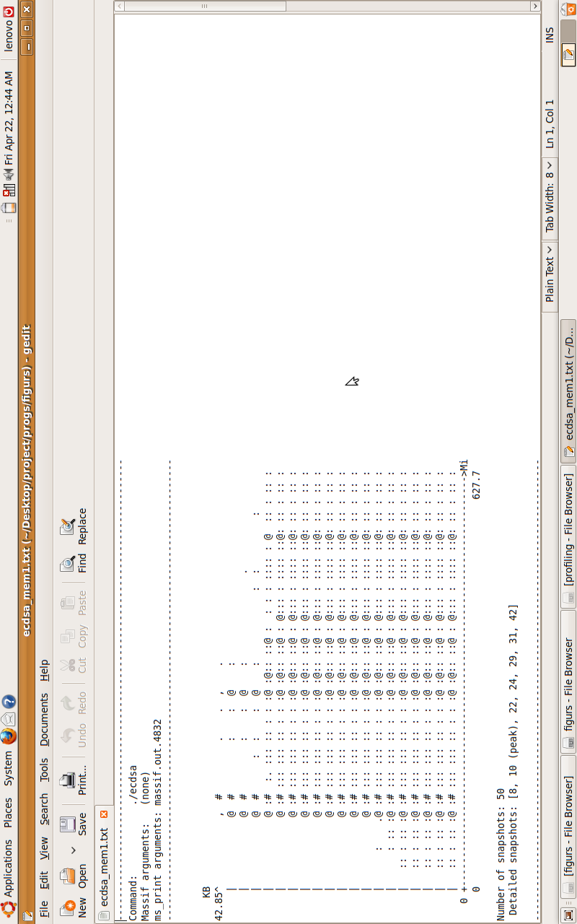
Figure 6.9: Screenshot of result obtained by msprint command in massif tool for ECDSA
Table 6.8: Sample Readings for peak values of heap memory consumed (bytes) by ECDH

Sample no. | time(i) | total heap | useful heap | extra heap | stack
5 | 21195983 | 6208 | 4656 | 1552 | 0
14 | 26844995 | 13416 | 10076 | 3340 | 0
23 | 32317249 | 14936 | 11108 | 3828 | 0
33 | 37707679 | 8808 | 6416 | 2392 | 0
42 (peak) | 42492883 | 15680 | 11776 | 3904 | 0
55 | 49145936 | 15344 | 11552 | 3792 | 0

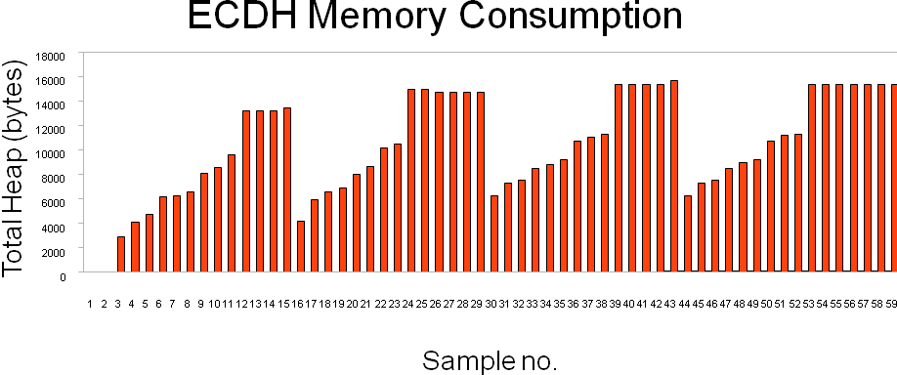
Figure 6.10: Plot of Sample Readings for heap memory consumed (bytes) by ECDH
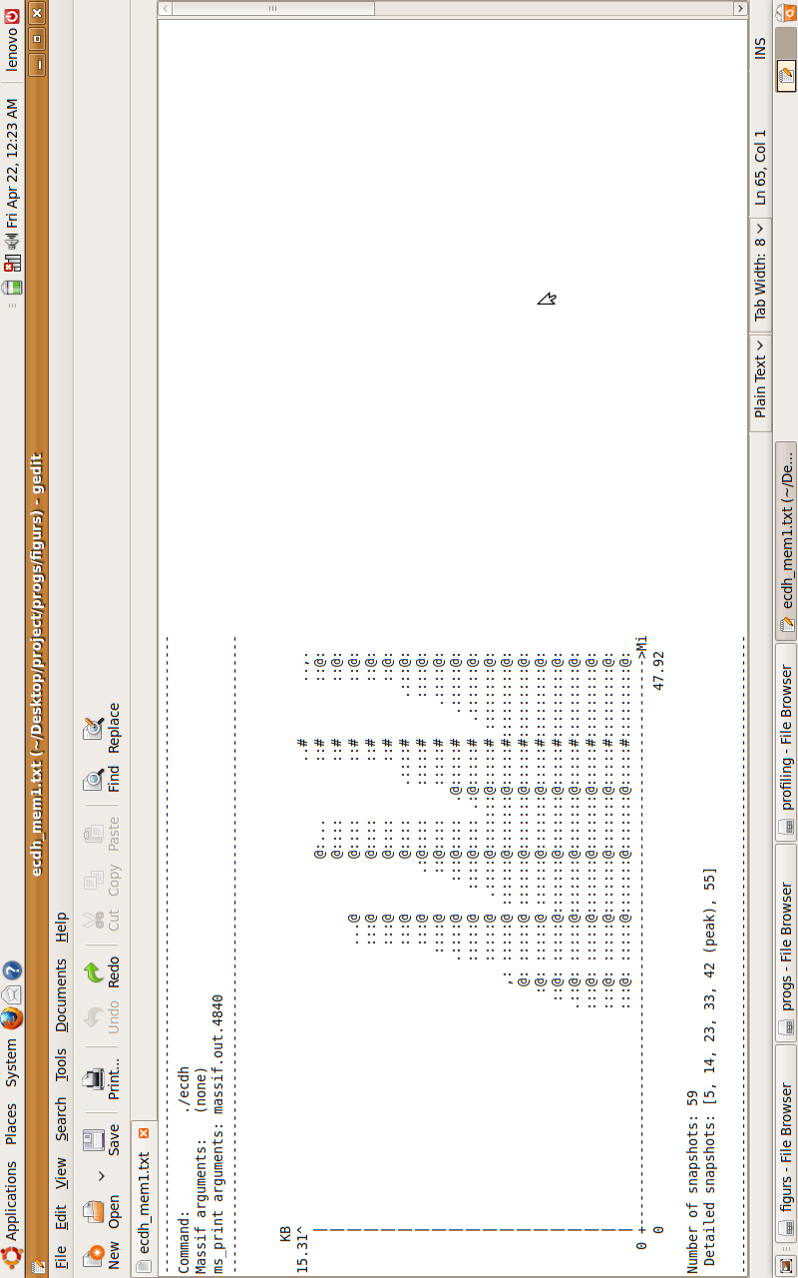
Figure 6.11: Screenshot of result obtained by msprint command in massif tool for ECDH
6.3 POWER CONSUMPTION
As discussed earlier, the power consumption would be obtained through the total Instruction Fetch (IF) cost parameter of the algorithms, for which the Valgrind tool Callgrind was employed. The following are the snapshots available from Kcachegrind.

Table 6.9: Total Instruction Fetch Cost for ECIES, ECDSA and ECDH

Algorithm | Total Instruction Fetch Cost
ECIES | 747 138 248
ECDSA | 688 745 567
ECDH | 52 746 600

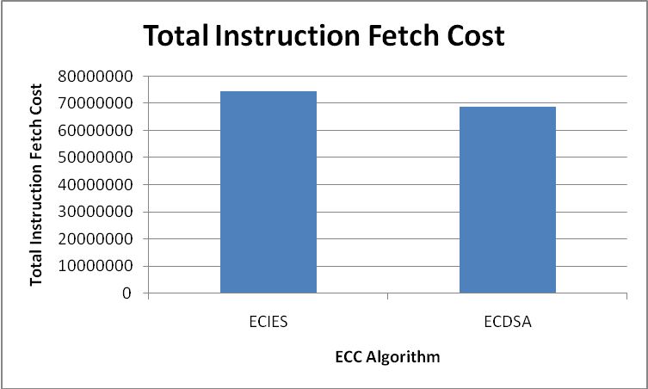
Figure 6.12: Graph of Total Instruction Fetch Cost of ECIES and ECDSA

Reason for the above results obtained is as follows:
PROGRAM | FUNCTION | INSTRUCTION FETCH COST
ECIES | Encryptor.Encrypt() | 375 066 958
ECIES | Decryptor.Decrypt() | 254 377 276
EDSSA | Signer.SignandRestart() | 193 260 215
EDSSA | Verifer.VerifyandRestart() | 373 410 525

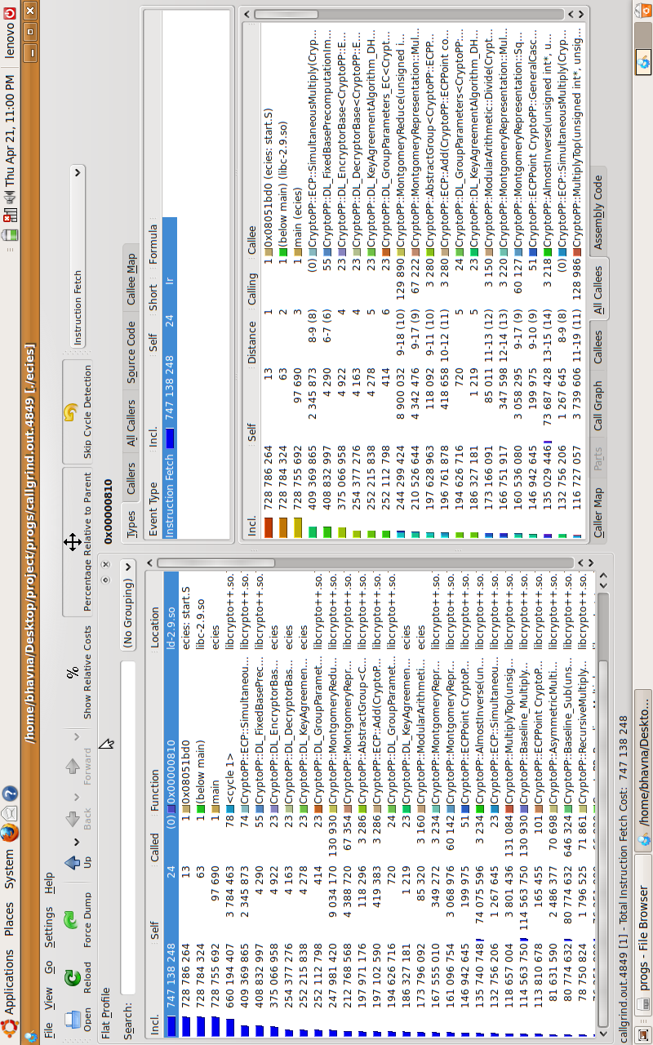
Figure 6.13: Screenshot of results obtained in Kcachegrind for ECIES
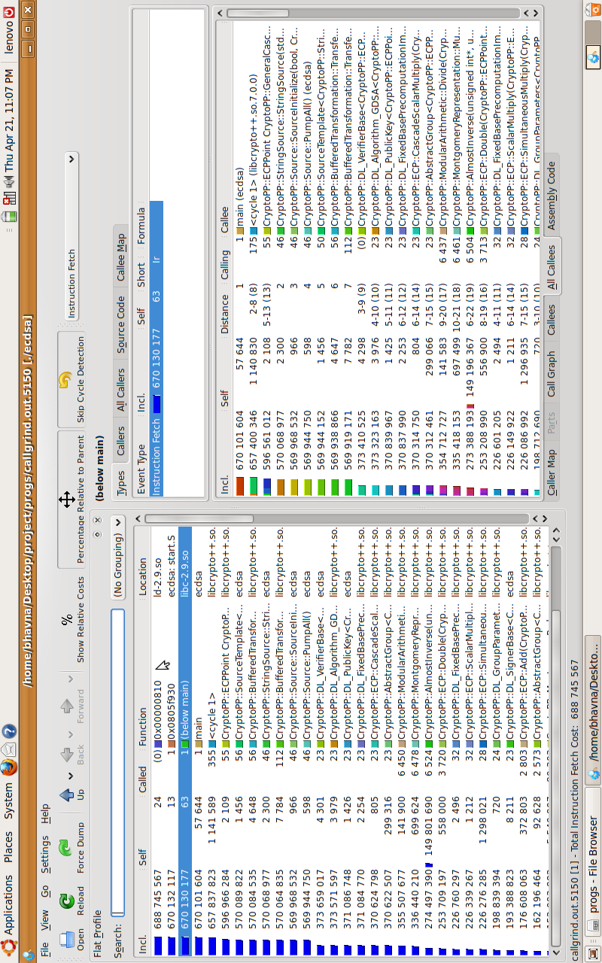
Figure 6.14: Screenshot of results obtained in Kcachegrind for ECDSA
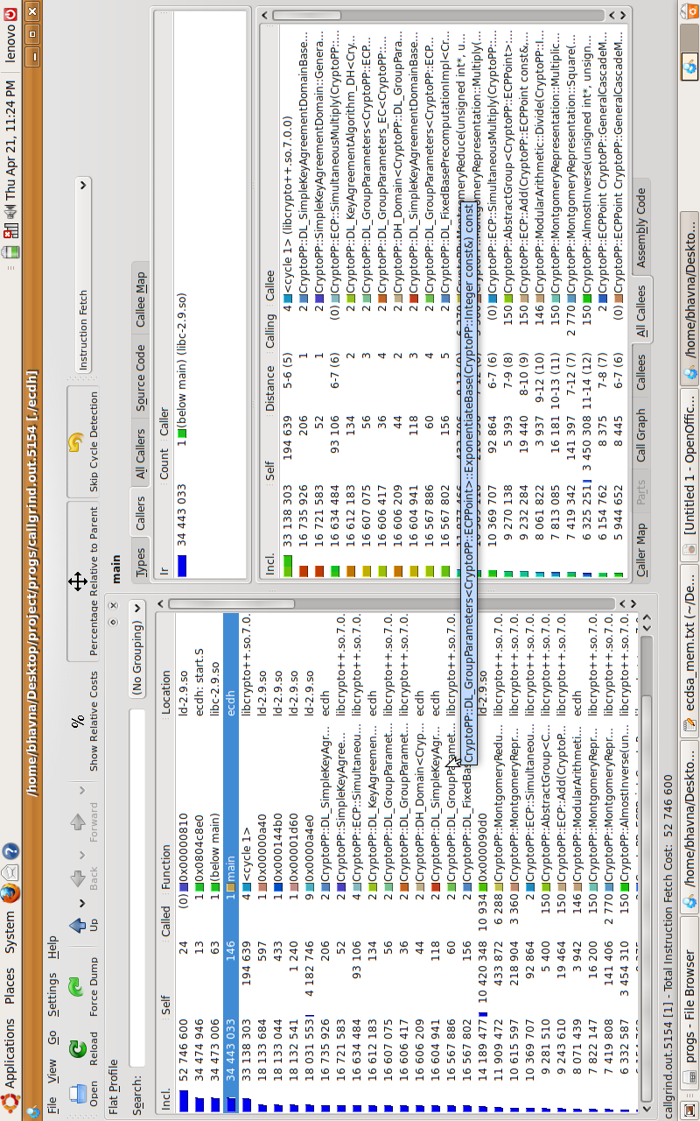
Figure 6.15: Screenshot of results obtained in Kcachegrind for ECDH
In time, memory and power constrained applications, and where authentication is of prime importance for e.g. cellular telephony, access control applications like web-based result, ATMs, physical entry to restricted areas or border crossings, ECDSA should be preferred over ECIES.
In applications where secrecy of communication is of prime importance, in comparison to time, memory and power consumed, for e.g. PIN no., credit card no. , defence communications, ECIES should be preferred.
CHAPTER 7
CONCLUSION AND FUTURE WORK

Conclusion
After studying and testing TinyECC, libecc and Crypto++ libraries; we found out that Crypto++ was suitable for our work. Henceforth, we implemented the three ECC algorithms, namely ECDSA, ECIES and ECDH using Crypto++ 5.5.2. Our work progressed further by searching for an appropriate profiling tool for runtime, memory and power consumption. After selecting Valgrind framework of tools for memory and power consumption, and the system call gettimeofday() for runtime profiling, we analysed the results and the algorithms for their suitability to different applications.

Future Work
This consists of:
- Extending each of the ECC algorithms viz. ECDSA, ECIES and ECDH to include the complete set of security features i.e. Confidentiality, Integrity and Authentication. For e.g. ECDSA (which provides authentication) could be extended to provide secrecy.
- Improvement on the individual algorithms in terms of performance and memory. For instance implementing ECMQV (Elliptic Curve Menezes-Qu-Vanstone) Key Agreement, an improvement over ECDH and provides protection against an active attacker. ECNR (Elliptic Curve Nyberg Rueppel) Signature Scheme, an improvement over ECDSA, could also be coded, analyzed and tested.
- Using the improvised algorithms and their results for use in Wireless Sensor Networks, where ECC algorithms hold prime importance in providing security in a memory and power constrained environment.
- Cross language implementation of ECC algorithms utilizing the capabilities and features of other languages like Java.
- Improving the performance, integration cost and overhead of inter-processor communication for ECC algorithms.

BIBLIOGRAPHY
- An Liu and Peng Ning, TinyECC: A Configurable Library for Elliptic Curve Cryptography in Wireless Sensor Networks in Proceedings of the 7th International conference on Information processing in sensor networks, 2008
- Barry Doyle et al., Security Considerations and Key Negotiation Techniques for Power Constrained Sensor Networks in The Computer Journal Advance Access, May 2006
- Hai Yan and Zhijie Jerry Shi, Studying Software Implementations of Elliptic Curve Cryptography in Proceedings of ITNG 2006, April 2006.
- Craig Gentry, Computing Arbitary Functions of Encrypted Data in Communications of the ACM, Volume 53, No. 3, March 2010.
- T. Kavitha and D. Sridharan, Security Vulnerabilities In Wireless Sensor Networks: A Survey in Journal of Information Assurance and Security, May 2010
- Anoop MS, Elliptic Curve Cryptography, An Implementation Guide, January 2007,
Available: http://hosteddocs.ittoolbox.com/AN1.5.07.pdf
- “http://en.wikipedia.org/wiki/Elliptic_curve_cryptography”. Last Accessed: 29th November, 2010
- An Liu, Readme for TinyECC Version 1.0, November 2007. Available: http://discovery.csc.ncsu.edu/software/TinyECC/README.txt
- directory.fsf.org/project/libecc/
- Daniel R. L. Brown, Certicom Research Standards for Efficient Cryptography – SEC 1: Elliptic curve cryptography, Version 1.0, September 2000. Available: “http://www.secg.org/download/aid-385/sec1_final.pdf”.
- “http://en.wikipedia.org/wiki/Crypto%2B%2B”. Last Accessed: 29th November, 2010
- Brian J. Gough and Richard M. Stallman, An Introduction to GCC - for the GNU compilers gcc and g++, Network Theory Limited, March 2004, Available:“http://www.network-theory.co.uk/docs/gccintro/gccintro_80.html”.
- “http://www.cs.utah.edu/dept/old/texinfo/as/gprof.html”. Last Accessed: 29th November, 2010
- “http://en.wikipedia.org/wiki/DTrace”. Last Accessed: 29th November, 2010
- “http://oprofile.sourceforge.net/about/”. Last Accessed: 29th November, 2010
- “http://en.wikipedia.org/wiki/ECIES”. Last Accessed: 29th November, 2010
- “http://en.wikipedia.org/wiki/Profiling_%28computer_programming%29”. Last Accessed: 29th November, 2010
- “http://linux.die.net/man/3/gettimeofday”. Last Accessed: 8th May 2011
- “http://valgrind.org/”. Last Accessed: 8th May 2011
- “http://valgrind.org/info/tools.html”. Last Accessed: 8th May 2011
ACKNOWLEDGEMENT

We would like to take this opportunity to bestow our acknowledgement to all the people who have directly or indirectly availed us in guiding my seminar. We are grateful to our college for giving us an opportunity to give seminar on this topic which will be the building step for our bright future.
We would like to express our sincere gratitude towards Dr. D. C. Jinwala, Head of Department and Associate Professor, COMPUTER ENGINEERING DEPARTMENT, our project guide, for giving us a chance to work on such an upcoming and interesting topic and for providing us with his supportive guidance, co-operation and advice.
We are grateful to Mr. Himanshu, Senior Research Fellow, ISRO Project, for chipping in with his invaluable suggestions for steering us on the right track.
I thank almighty God and my parents for their constant support and blessings in all my pursuits.

